SE-Overview Of IT Industry

Question 1: What is software? What is software engineering?

Answer:

Software is a set of instructions, data or programs used to operate computers and execute specific tasks.

Ex->

* Adobe Photoshop.
* Picasa.
* VLC Media Player.
* Windows Media Player.

Software Engineering is a detailed study of engineering to the design, development and maintenance of software.

Question 2: Explain types of software.

Answer:

* **Application software-**

Application software is a computer software package that performs a specific function for a user or for another application.

Ex-> web browsers, word processors, software development tools, image editors

* **System software-**

**Software programs are designed to run a computer's application programs and hardware.**

**Ex-> OS,Firmware**

* **Driver software-**

**This software is often considered a type of system software. Device drivers control the devices and peripherals connected to a computer, enabling them to perform their specific tasks.**

* **Middleware-**

**Software that mediates between application and system software or between two different kinds of application software.**

* **Programming Software-**

**Programming software and programming tools enable developers to develop, write, test and debug other software programs.**

Question 3: What is SDLC? Explain each phase of SDLC.

Answer:

SDLC->Software Development Life Cycle

The Software Development Life Cycle is a framework that defines the steps involved in the development of software at each phase.

Phases of SDLC—

* Analysis

During this phase, all the relevant information is collected from the customer to develop a product as per their expectation.

* Design

In this phase, the requirement gathered in the SRS document is used as an input and software architecture that is used for implementing system development is derived.

* Implementation

Implementation starts once the developer gets the Design document. The Software design is translated into source code. All the components of the software are implemented in this phase.

* Testing

Testing starts once the coding is complete and the modules are released for testing. In this phase, the developed software is tested thoroughly and any defects found are assigned to developers to get them fixed.

* Deployment

Once the product is tested, it is deployed in the production environment.

* Maintenance

After the deployment of a product on the production environment, maintenance of the product if any issue comes up and needs to be fixed or any enhancement is to be done is taken care by the developers.

Question 4: What is DFD? Create a DFD diagram on Flipkart.

Answer:

DFD->Data Flow Diagram

 Data Flow Diagram. The flow of data of a system or a process is represented by DFD. It also gives insight into the inputs and outputs of each entity and the process itself.

Question 5: What is Flow chart? Create a flowchart to make addition of two numbers.

Answer:

A flowchart is a picture of boxes that indicates the process flow sequentially.

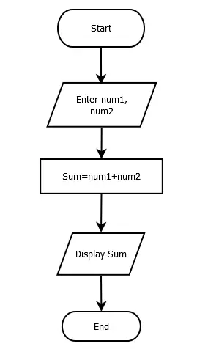

Question 6: What is Use case Diagram? Create a use-case on bill payment on paytm.

Answer: A use case diagram is a way to summarize details of a system and the users within that system.

